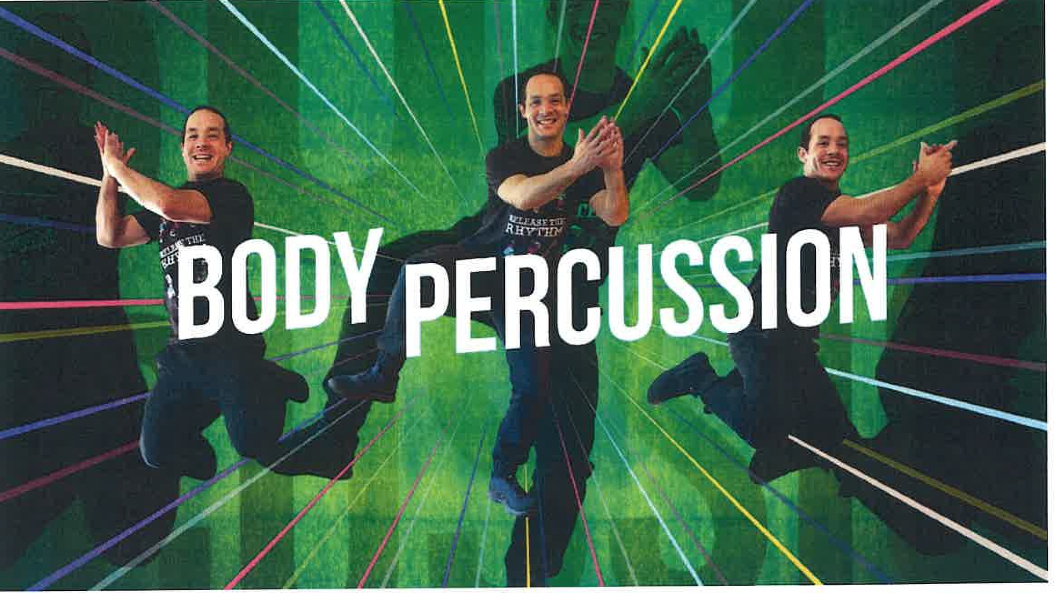

'Digitally Streamed' Workshops Thank you for booking our new Body Percussion workshops.
These workshops will be delivered via Zoom or Google Meets and
streamed directly into your classroom or gym hall.
Students will go on a rhythmic journey around the world to discover how other countries & cultures create music just using their bodies. While learning new skills and techniques, students will learn some of the history and cultural background to Body Percussion.
Through these physical fun creative workshops, students
will use their new skills to create positive 'Resilient Rhythms' together.
I.e. Body Percussion beats that use the rhythm of positive phrases about "Not giving up" & "Keep going"

